Smart Parking System — Full Product
Documentation (SRS + Architecture + Flow + Diagrams)

Executive Summary
We are building a next-generation smart parking system (web + mobile app) that does more than showing nearby parking — it guarantees a parking spot, optimizes costs, reduces search time, and lowers emissions.
What makes it unique?
Capability | Existing apps (Google Maps / SpotHero / Parkopedia) | Our Platform
Show parking spots | ✅ | ✅
Live spot availability via Computer Vision (CV) | ❌ | ✅
Guaranteed parking (queue + reassignment logic) | ❌ | ✅
No penalty for overstaying (auto billing instead) | ❌ | ✅
Second user compensation via wallet credits | ❌ | ✅
CO₂ impact scoring (g CO₂ + % savings) | ❌ | ✅
AR indoor navigation to the exact parking spot | ❌ | ✅
Marketplace — private individuals list their spot (Airbnb-style) | ❌ | ✅
Business Impact
- Saves user time + money + emissions
- Creates B2B monetization: subscriptions for mall/shopping center operators
- Enables P2P revenue sharing (private spot owners earn money)
- Data/analytics valuable for city planning & sustainability reports

2) Problem & Goals
Problem Statement:
Urban drivers spend 7–14 minutes on average searching for parking.
This wastes fuel, money, time, and produces CO₂ emissions.
Current industry gaps:
- No real-time spot availability
- No guarantee of a spot even after reservation
- No wallet compensation for inconvenience
- No CO₂ scoring / eco optimization
- No indoor AR guidance / layout visualization
Primary Goals
- Accurate search + live availability
- Guaranteed parking spot using queue system + reassignment
- Minimize circling time, fuel cost & CO₂ output
- Support EV requirements (charger, kW, cost)
- Allow reservations and payments (Card, Wallet, UPI)
- Marketplace: list private driveways / commercial parking
- Operator portal to manage lots, tariffs, spot layouts, and availability
Non-Goals (future phases)
- Automated barrier open via LPR (license plate recognition)
- Dynamic surge pricing
- Government contracts and smart city integrations

3) Personas & Use Cases
Personas
Persona | Needs / Pain Points
Driver (ICE/EV) | Wants cheapest/closest parking, guaranteed availability
EV Owner | Needs charging spots by connector type (CCS2, Type2, NACS, etc.)
Queued User | Wants spot reassignment or compensation if original spot unavailable
Private Spot Owner | Wants to earn money by renting unused driveway
Parking Operator (Admin) | Wants dashboard, pricing, layouts, analytics
City / Campus Admin | Wants traffic reduction + sustainability metrics
Top Use Cases
- Search “destination” → show minimum 10 results within 1.5–5 km
- Rank by: Price | Distance | Availability | CO₂ savings
- Select spot → reserve → pay → navigate via AR

4) Functional Requirements
4.1 Location & Search
- Search via autocomplete (Google Maps / OSM Nominatim)
- Minimum 10 results within 1.5–5 km
- Sorting:
  - Cheapest → Most expensive
  - Nearest → Farthest
  - Lowest CO₂ → Highest CO₂
- Toggle: "Only show available spots"
4.2 Results & Filters
Filters include:
- Price slider
- EV charging (connector / kW)
- Covered parking / CCTV
- Free parking
- Accessibility bays
- Height limits
Badges include:
- 🟢 Green Choice (lowest CO₂)
- 💸 Cheapest
- 🚶 Closest
- 🔌 EV Compatible
- ⭐ Best Value Score
4.3 Computer Vision (Live Availability)
Data sources:
- CCTV camera
- Edge devices (ESP32 camera or PiCam)
- Phone camera (user scanning)
Output:
- Spot occupancy (free / occupied / reserved)
- Spot metadata (EV / accessible / regular)
4.4 Reservation & Queue Guarantee
- User reserves a spot
- Queue manager places others in waitlist
- If current user extends stay:
  - No penalty to them → auto billing
  - Queued user gets:
    - Nearest reassigned spot, OR
    - Wallet compensation
4.5 Wallet Compensation
- Credit stored & usable on next booking
- No expiry
4.6 Private Parking Marketplace
- Homeowners or shop owners list spots
- Users can book those like Airbnb

5) Non-Functional Requirements
Category | Requirement
Performance | Search API < 400ms (cached), lot detail < 600ms
Availability | 99.9% uptime (single region)
Security | OAuth2 + JWT + RBAC
Privacy | GDPR/CPRA compliant
Payments | PCI-DSS SAQ-A (tokenized)
Observability | OpenTelemetry, logs, distributed tracing

6) System Architecture (Updated)
[ Mobile / Web App ]
|
HTTPS + JWT
|
[ API Gateway ]
|
┌─────────────────────────┬───────────────────────┬────────────────────────┐
| | | |
[Search Service] [Reservation + Queue] [Wallet + Payment] [Maps Adapter]
| | | |
[CO₂ Engine] [Spot Reassign Logic] [Stripe/Razorpay/UPI] [Google/OSM]
|
[Emission Factor DB]

[Computer Vision Service] <-- CCTV / ESP32 cameras / Drone feed

[Postgres + PostGIS] ← layouts, lots, spots, reservations
[Redis Cache] ← caching search, quotes

7) Data Model (ERD Outline)
Entities (highlights):
- Reservation.spot_id, queue_position
- Wallet(balance) for compensation
- EmissionFactor(region, g_co2_per_km, g_co2_per_kwh)

8) API (Draft)
API | Description
POST /reservations | Create reservation
PUT /reservations/{id}/extend | Extend reservation (auto billing)
POST /queue/reassign | Assign new spot for queued user
POST /wallet/refund | Compensation credit
POST /co2/score | Returns g CO₂ + % savings
More APIs exist; full list in Section 8.

9) Ranking & Scoring Logic
BestValueScore =
w_price * normalized(price) +
w_distance * normalized(distance) +
w_availability * normalized(availability) +
w_co2 * normalized(co2) +
w_rating * normalized(rating)

10) CO₂ Footprint Calculation
ICE vehicle:
CO₂ = (route_km + cruising_km) * emission_factor_g_per_km

EV:
CO₂ = (route_km * efficiency_kWh/km) * grid_intensity_g/kWh
App shows:
You saved 420g CO₂ vs normal street parking ✅

11) Lot Layout & Spot Rendering (Per-spot visualization)
Parking lots are represented as multi-level polygon layouts with spot objects.
Features:
- Floors (Level 1, Level 2…)
- Aisles + zones
- Spot polygons (GeoJSON)
- Real-time status overlays (free/occupied/reserved/EV/etc.)
- Tap to see metadata (spot size, restrictions, EV connector type)
Spot colors:
Color | Meaning
🟢 Green | Available
🔴 Red | Occupied
🔵 Blue | Reserved
🟦 Teal | EV charging spot (live charging status)
🟣 Purple | Accessibility spot

12) Integrations (Maps, EV networks, Payment, CV)
Integration | API Used | Reason
Google Maps Platform | Geocoding, Directions, Distance Matrix, Static/JS Maps | Search + navigation
EV Networks | OCPI/OCPP, OpenChargeMap, Hubject | EV charger availability
Payments | UPI / Stripe / Razorpay / Paytm | Secure payment + refunds
Computer Vision | Python (YOLOv8), OpenCV, ESP32 Cam / CCTV stream | Spot occupancy detection
Where needed, OpenStreetMap + MapLibre can be used to reduce Google API billing costs.

13) Frontend (Modern GUI)
Tech stack (web):
- React + TypeScript
- Tailwind + shadcn/ui components
- Zustand / Redux Toolkit (state management)
- React Query (data fetching)
Design features:
- PWA (works as app on mobile without install)
- Dark/light mode
- Responsive design
- AR view overlay using WebAR (model-viewer + ARCore/ARKit)
App views:
Screen | Key Elements
Search | Map + list results, filters
Lot Detail | EV chargers, CO₂ score, price estimate
Layout View | Level view + spot selection in real time
Checkout | Payment + wallet + UPI
AR Navigation | Arrow overlay guiding user to the exact spot

14) Backend & Data Infrastructure
Component | Tech
Backend API | Python (FastAPI) or Node.js (NestJS)
DB | PostgreSQL + PostGIS (spatial data)
Cache | Redis (search caching + pre-scored results)
Message brokers | Kafka / NATS (queue & CV events)
Storage | S3 bucket (blueprints & images)
Realtime | WebSockets / SSE for live layout updates
Database stores:
- Parking lots and layouts as GeoJSON
- Individual spots (bounding polygon)
- Reservation and wallet transactions

15) IoT (Computer Vision Spot Detection)
Hardware optional (lots without cameras can manually update spot status).
Supported CV inputs:
- CCTV live stream → YOLOv8 detecting occupied spots
- ESP32 Cam (cheap IoT camera)
- Drone feed (university/large event use case)

16) Security, Privacy & Compliance
Area | Measure
Authentication | OAuth2.1 + OIDC + JWT
Access control | RBAC (User / Spot Owner / Operator / Admin)
Transport | TLS 1.3, HSTS, HTTPS only
Data | PII encrypted, wallet tokens encrypted
Compliance | GDPR/CPRA + PCI DSS SAQ-A
Threat mitigation | Rate limiting, WAF, Anti-DDoS, anomaly detection
Privacy: No license plates stored; if CV is used, frames are processed edge-side and not stored.

17) DevOps & SRE (Reliability)
Category | Selected Approach
Infra | Kubernetes (EKS/GKE/AKS)
CI/CD | GitHub Actions + automated Docker build
IaC | Terraform
Monitoring | OpenTelemetry + Prometheus + Grafana
Logging | ELK / CloudWatch
On-call | PagerDuty

18) Analytics & Experimentation
Key KPIs:
- Search → reservation conversion rate
- CO₂ saved per reservation (% vs average street parking)
- Average wallet compensation amount
- EV parking adoption rate
A/B Testing examples:
- Which filter increases conversion: "Cheapest" vs. "Lowest CO₂"?
- Should CO₂ savings be shown in % or grams?

19) Acceptance Criteria (MVP Completion)
Requirement | Must Pass?
Search shows ≥ 10 results within 1.5–5 km | ✅
User can reserve a spot and navigate via AR | ✅
If spot unavailable → queued user receives reassignment or compensation | ✅
EV filter shows only valid chargers | ✅
CO₂ score displayed in results + detail screen | ✅

20) Testing Strategy
Testing Type | Tools
Unit tests | PyTest / Jest
API Tests | Postman / Newman
E2E UI | Playwright / Cypress
Load Test | k6 / Gatling
Security Scans | Snyk + Trivy
CV Model accuracy | YOLO metrics (precision/recall)

21) Roadmap (Phased Delivery)
Phase | Duration | Deliverables
Phase 0 | 2–3 weeks | CV PoC, initial DB + search
Phase 1 | 6–8 weeks | MVP app + layout view + CO₂ + operator portal
Phase 2 | 4–6 weeks | Wallet + queue system + AR guidance
Phase 3 | 8+ weeks | Marketplace + CV IoT automation + smart contracts

22) Risks & Mitigations
Risk | Mitigation
Camera not reliably detecting spots | Fallback: manual operator update
Queued user frustration | Wallet credit + reassignment option
Google Maps API cost | Cache + OpenStreetMap fallback

23) Open Questions
- Do we enable automated gate entry in v2?
- Should wallet credits be transferable or redeemable for cash?

24) Appendix
CO₂ estimate example shown to user:
"⭐ You saved 420g CO₂ vs. typical street parking"

25) Glossary
Term | Definition
CV | Computer Vision
CO₂ Score | Estimated emissions for selected spot
RBAC | Role-based access control

1. Project Overview
The Smart Parking System is a next‑generation platform combining: - Computer Vision (AI detection of free/occupied parking spots) - Spot reservation with queue management - Auto billing on overtime (no penalties, only normal billing) - Wallet compensation if reassignment happens - Marketplace for private parking owners (Airbnb for parking) - AR navigation to guide the user to the specific spot Goal: Ensure the user always finds parking, even if their reserved spot becomes unavailable.

2. Unique Selling Proposition (USP)
Not just find parking, but guarantee a parking spot.
Feature Exists Today? Our System
Find nearby parking | ✅ | ✅
Exact spot detection via AI (CCTV / Phone camera) | ❌ | ✅
Queue + automatic reassignment + wallet compensation | ❌ | ✅
Auto-billing when user overstays (no penalty) | ❌ | ✅
AR indoor parking guidance | ❌ | ✅
Private parking marketplace | ❌ | ✅

3. Actors
Actor Role
User (Driver) Search, reserve, pay, navigate
Actor Role
Admin (Parking Operator) | Manage lots, layouts, availability
Private Parking Owner | Lists parking as marketplace spot
Payment Gateway | UPI/Card wallet billing
Computer Vision Service | Detects free/occupied spots
Maps API / AR Service | Guides user to exact location

4. Functional Requirements

4.0 Newly Added — CO₂ Footprint Optimization (Eco‑Smart Parking)
The system automatically calculates and labels carbon footprint for each parking option and shows CO₂ savings (%) compared to the highest‑impact option on the list.
Inputs: distance to parking, availability (circling), vehicle type (ICE/EV), regional CO₂ factors.
Displayed to user:
Eco impact: 180g CO₂ | Savings: 28% vs highest‑impact option
320g CO₂ | Savings: 12% vs highest‑impact option
520g CO₂ | Highest CO₂ (baseline)
Calculation logic: - ICE: CO₂ = distance_km × emission_factor_g_per_km - EV: CO₂ = energy_kWh × grid_intensity_g_per_kWh - Savings % formula: savings_pct = (max_co2 - option_co2) / max_co2 × 100
Sort option: Sort by Lowest CO₂
Badges on result: Eco Choice — lowest emission option

5. Non‑Functional Requirements
Non-Functional Requirements - Search results: < 400ms - System uptime: 99.9% - Seat detection inference time: < 200ms - Database: PostgreSQL + PostGIS

6. System Architecture (High Level)
Mobile/Web App
│
▼
API Gateway
→
Auth Service (JWT)
│
├──
Parking Search Service
→
DB (Parking Lots + Private Listings)
├──
Reservation + Queue Manager
→
Wallet Service
→
Payment API
├──
Computer Vision Service
→
Camera Feed / CCTV / Drone
└──
AR Navigation Service
→
Maps API

7. Queue Conflict Handling Logic (Final)
If user A extends time:
charge user A based on new time
If alternate spot exists:
assign to user B
Else:
show popup with options (assign, wait, cancel)
If cancel:
refund(userB)
→
Wallet credits

8. Diagrams (Use Case + Flow + Sequence)
Diagram style: Lucidchart (enterprise style). You can import these using Lucidchart’s PlantUML/Text import, or render via PlantUML and upload SVG/PNG into Lucidchart for collaboration.

8.1 Use Case Diagram (with external systems)
@startuml
left to right direction
skinparam actorStyle awesome
skinparam packageStyle rectangle
actor "Driver / User" as User
actor "Admin / Parking Operator" as Admin
actor "Payment Gateway (UPI / Card / Wallet)" as Pay
actor "Maps / AR Service" as Maps
actor "Computer Vision Service" as CV actor "EV / Open Data Providers" as EV
rectangle "Smart Parking System" {
' Authentication first
(Login / Sign Up) as UC_Login
User --> UC_Login
Admin --> UC_Login
' Discovery
(Search parking near destination) as UC_Search
(Apply filters: Price / Distance / EV / Free / Paid) as UC_Filter
(View lot details) as UC_Detail
(View layout & spot status) as UC_Layout
User --> UC_Search
User --> UC_Filter
User --> UC_Detail
User --> UC_Layout
CV --> UC_Layout
EV --> UC_Detail
' Reservation / Queue / Wallet
(Select spot & Reserve) as UC_Reserve
(Join queue for spot) as UC_Queue
(Popup: Reassign / Keep Waiting / Wallet Refund) as UC_Popup
(Wallet credits) as UC_Wallet
User --> UC_Reserve
User --> UC_Queue
UC_Queue ..> UC_Popup : <<extends>>
UC_Popup ..> UC_Wallet : <<uses>>
' Billing & Payment
(Auto-billing on overstay) as UC_Overstay
(Pay via UPI/Card/Wallet) as UC_Pay
User --> UC_Pay
Pay --> UC_Pay
User --> UC_Overstay
' Navigation
(AR guidance to exact spot) as UC_AR
User --> UC_AR
Maps --> UC_AR
' Admin portal
(Create/Edit lot & pricing) as UC_AdminLots
(Upload layout & classify spots) as UC_AdminLayout
(Update availability) as UC_AdminAvail
(View analytics dashboard) as UC_AdminAnalytics
Admin --> UC_AdminLots
Admin --> UC_AdminLayout
Admin --> UC_AdminAvail
Admin --> UC_AdminAnalytics
}
@enduml

8.2 Sequence Diagram — Queue Conflict & Reassignment (Option B wording)
@startuml
actor UserB as "Queued User (B)"
participant App as "Mobile/Web App"
participant API as "Backend API"
participant Queue as "Queue Manager"
participant Lots as "Lot/Spot Service"
participant Wallet as "Wallet Service"
participant Pay as "Payment Gateway"
participant UserA as "Current User (A)"
==
A extends reservation
==
UserA -> App : Extend time
App -> API : PUT /reservations/{id}/extend
API -> Pay : Charge extra (normal billing)
Pay --> API : Success
API --> App : Extension confirmed
==
Notify queued user
==
API -> Queue : Spot still occupied; notify next in queue
Queue -> App : Push event (spot unavailable)
App -> UserB : **Popup**
[
Reassign me] [Keep waiting] [Cancel & refund to wallet
]
alt UserB chooses "Reassign me"
App -> API : POST /queue/reassign {pref: nearest}
API -> Lots : Find nearest available spot
Lots --> API : Spot B18
API -> App : Assign Spot B18 + navigate
end
alt UserB chooses "Keep waiting"
App -> API : POST /queue/wait
API -> Queue : Keep position; ETA updates
Queue --> App : Live ETA events
end
alt UserB chooses "Cancel & refund to wallet"
App -> API : POST /queue/cancel
API -> Wallet : credit(amount)
Wallet --> API : ok
API -> App : Wallet refund confirmed
end
@enduml

8.3 Component / Architecture Diagram (High Level)
@startuml
skinparam componentStyle rectangle
package "Clients" {
[iOS/Android PWA]
[Web App]
}
package "Edge / CV" {
[CCTV / PiCam / Drone]
[CV Inference Service]
}
package "Core Services" {
[API Gateway]
[Auth Service]
[Search Service]
[Lot & Layout Service]
[Reservation & Queue Manager]
[Wallet Service]
[Payment Adapter]
[AR/Maps Adapter]
}
package "Data Stores" {
[Postgres + PostGIS]
[Redis Cache]
[Object Storage (Layouts/Images)]
}
package "External Providers" {
[Payment Gateway]
[Maps / AR]
[EV / Open Data]
}
[
iOS/Android PWA] --> [API Gateway
]
[
Web App] --> [API Gateway
]
[
CCTV / PiCam / Drone] --> [CV Inference Service
]
[
CV Inference Service] --> [Lot & Layout Service
]
[
API Gateway] --> [Auth Service
]
[
API Gateway] --> [Search Service
]
[
API Gateway] --> [Reservation & Queue Manager
]
[
API Gateway] --> [Lot & Layout Service
]
[
API Gateway] --> [Wallet Service
]
[
API Gateway] --> [Payment Adapter
]
[
API Gateway] --> [AR/Maps Adapter
]
[
Search Service] --> [Postgres + PostGIS
]
[
Lot & Layout Service] --> [Postgres + PostGIS
]
[
Reservation & Queue Manager] --> [Postgres + PostGIS
]
[
Wallet Service] --> [Postgres + PostGIS
]
[
All components] --> [Redis Cache
]
[
Payment Adapter] --> [Payment Gateway
]
[
AR/Maps Adapter] --> [Maps / AR
]
[
Lot & Layout Service] --> [Object Storage (Layouts/Images
)]
[
Lot & Layout Service] --> [EV / Open Data
]
@enduml

8.4 Lucidchart Layout & Export Guidelines
- Canvas: 16:9, dark header, light content sections. Fonts: Inter or Roboto.
- Swimlanes: Left actors (Users/Operators), center system, right external systems (Payments/Maps/ CV).
- Colors:
- Primary: #15B77E (actions, primary use cases)
- Secondary: #1A73E8 (external systems / integrations)
- Accent: #FFCC00 (warnings / queue popups)
- Connectors: Straight lines with arrowheads; label extension relationships as extends/uses.
- Import paths: 1) File Import Data UML (PlantUML/Text) and paste blocks; or 2) Render via https:// www.plantuml.com/plantuml/uml Export SVG Insert into Lucidchart.
- Export: Share as PNG @2x for docs and PDF for PPT.

9. Wallet Rules
- Credits never expire
- Compensation amount decided by severity

10. Marketplace (Private Parking Owners)
- User can rent out driveway/parking
- Revenue sharing model: 90% owner / 10% platform

11. UI/UX Requirements
- Clean modern UI (Tailwind + React / Flutter)
- AR overlay must be simplified for low-light parking areas

12. Deliverables
Deliverable Owner Status
System Architecture Diagram | Architect | Pending
Use Case Diagram (PNG) | Product/UX | Completed
ERD Diagram (PNG) | Backend/DB | Completed
PPT (diagrams embedded) | Product/PM | Completed
UI Wireframes | UX Designer | Pending

13. Embedded Diagrams
These images are exported assets; download links are available in the chat, and previews are embedded below.
13.1 Use Case Diagram (v3 — with CO₂ engine)
Use Case Diagram v3

13.2 ERD Diagram (v4 — with EmissionFactors)
ERD Diagram v4 (v3 — updated with CO₂ emissions)
ERD updated to include
EmissionFactors
table and
co2_estimated_g
in
Reservation
.
ERD Diagram v3
End of Document

Hierarchy diagram

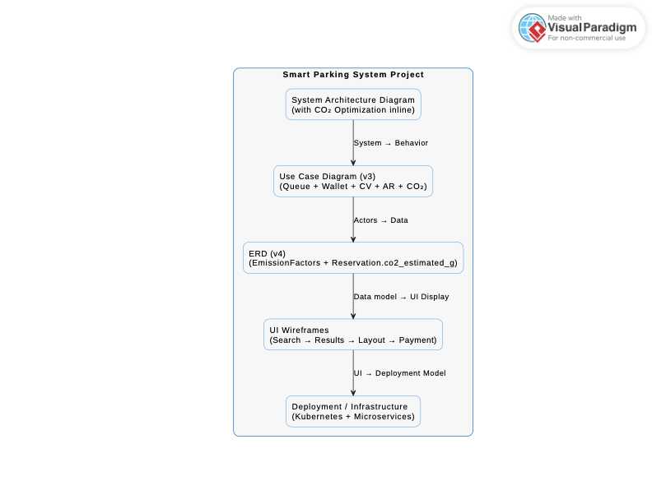

Mind Diagram

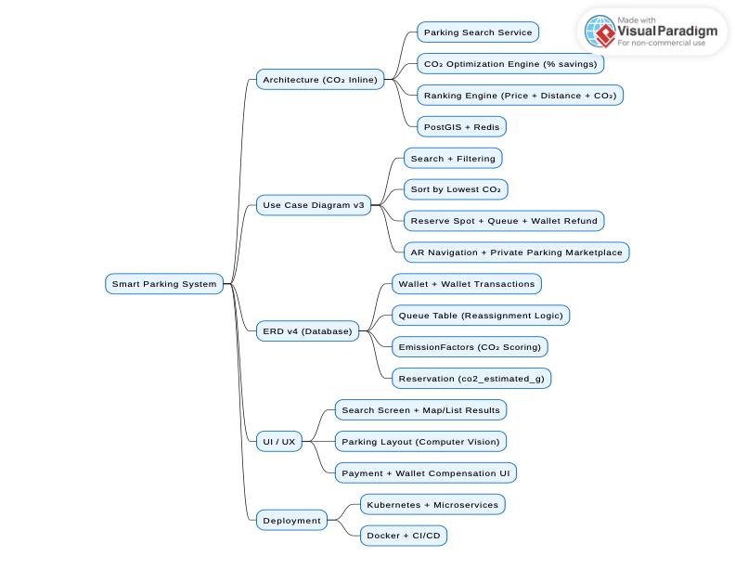

UI navigation diagram user
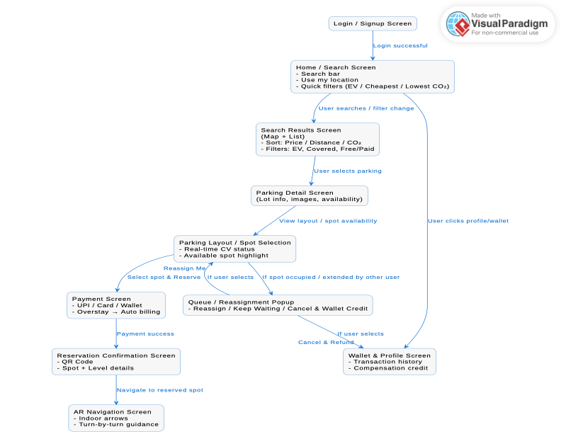
Ui navigation diagram admin

